NAME:MONIKA.B
REG. NO: 192571002

EXPERIMENT – 20
MYSQL String Functions- REPLACE, REPEAT, REVERSE, RIGHT, LEFT, RPAD, LPAD
REPLACE, REPEAT, REVERSE, RIGHT:
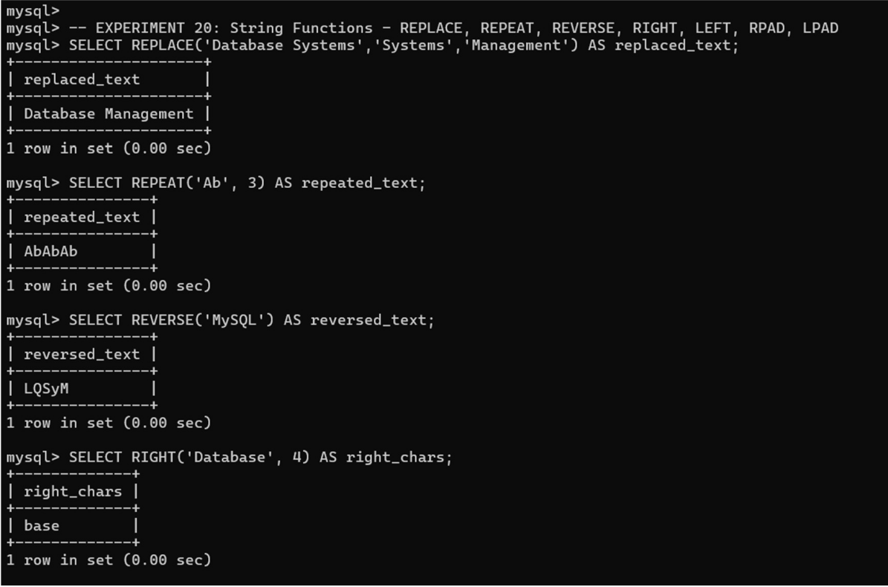

LEFT, RPAD, LPAD:
